Omar Burney and Anh Pham

1. **Show ONE instance of data** that you will use, with ALL fields:

* Json format (stores movie title, release year, director name, critic rating, and runtime):

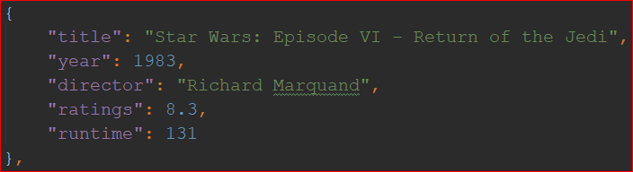

2. **Show the size of your data set**: how many data records will you work with?

The JSON file above has approximately 250 movies stored inside of it and will allow for querying the data below per movie when the user wants to view the specific data outside of the JSON file, for example, the movie plot. The database being pulled from has around 280k movies in its own database which the user can search from to add to their local database.

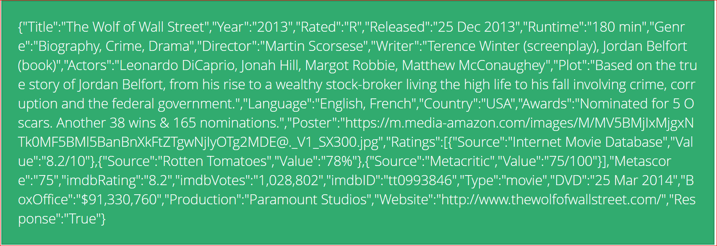

3. Think about the GUI of the app:

- will the user see some aspects of the data when the application comes up?

No

- what choices do they have with the data?

View movies sorted by IMDB’s ranking, release year, and runtime

Plot the movies by rating, release year, and runtime

Insert movie (from API) into local database

- what will the application show at each user choice?

For choice 1.1 - 1.3: list of movie names

For choice 1.4: show movie data of clicked movie

For choice 2: graphs of the number of movies that fits the criteria selected

For choice 3: search bar and movie names

Start: Show the options that user can choose:

|-- Choice 1: View movie data

| |-- Choice 1.1: Sort by rank

| |

| |-- Choice 1.2: Sort by release year

| |

| |-- Choice 1.3: Sort by runtime

| |

| |-- Choice 1.4: Select movie

| |-- show movie data (using API)

|

|-- Choice 2: Analyze movie data

| |-- Choice 2.1: movie ratings

| | |-- Plot number of movies based on rating (histogram)

| |

| |-- Choice 2.2: movie runtime

| | |-- Plot number of movies based on runtime (histogram)

|

|-- Choice 3: Insert movie into local database

| |

| |-- Choice 3.1: Search movie by name

| | |-- 3.1.1 display list of movies that match what they type

| | |-- 3.1.2 Select Movie from returned list of movies

| | | |-- grab data and save it into local database

4. Members:

Anh Pham: Choice 1.1 - 1.3, choice 3.1.2

Omar Burney: choice 1.4, choice 2, choice 3.1.1